20/33 – The Four Gospels – 01/24/16

Key thought: The four Gospels in the New Testament tell about Jesus’ ministry as the Savior. Each of them tells the story from a different point of view. Together, they help us to get a deeper understanding of Jesus as a person and of the work He did for us.

All the Gospels contain historical records. They are, however, not biographies in the strict sense, but testimonies of faith in which Christ is proclaimed. The first three Gospels are called “synoptic” because they have a “common view” of the ministry of the Lord. John follows a different approach; it represents theological reflections on the person and work of Christ at a later date.
Each of the Gospels is a distinctive portrait of Jesus, stressing certain features of His ministry in answer to special questions and problems in the church for which it was written.

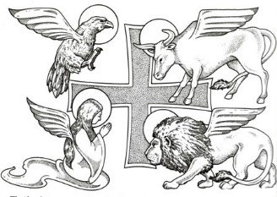

Matthew: the winged man
Jesus is the long-awaited Messiah, who:
- fulfills God's promises to His Old Testament people;
- teaches about God's Kingdom and His will for those who follow Him;
- dies for our sins and, after He has risen again, sends out His followers to tell the Good News to all people.

Mark: the winged lion
Jesus is the strong deliverer sent by God, who:
- has power and authority over sickness, nature, demons, and death;
- dies to set us free from sin, and conquers death by rising triumphantly on the third day.

Luke: the winged ox
Jesus is the living savior of all, who:
- reaches out to help the troubled and outcast;
- teaches about His Father's love and forgiveness;
- lays down His life for sinners, and rises again to show that He has won the victory.

John: the eagle
Jesus is the true son of God, who:
- became a man and lived among us as the Savior who reveals His Father's love;
- shows His glory by His works and through His suffering and dying for us;
- conquers death so that all who believe in Him may be His friends forever.

Part 20/33 – The Four Gospels – Bible Study

For discussion

1. Discuss the value of having four different accounts of Jesus life and work.

2. Read Matthew 4:12–25. In Jesus the Old Testament prophecies came true. He is the long promised prophet, who carried on a ministry of love as the Servant of the Lord. Find other references which illustrate Matthew’s picture of Jesus.

3. Read Mark 1:21–28. Jesus is the strong deliver sent by God to conquer the power of darkness. Find other references which illustrate marks picture of Jesus.

4. Read Luke 5:27–32. Jesus is the loving Savior of all who reaches out to help also the outcasts. Find other references which illustrate Luke’s picture of Jesus.

5. Read John 5:19–29. Jesus is the Son of God who came to reveal His heavenly Father and to give eternal life to all who believe. Find other references which illustrate John’s picture of Jesus.

